CS 255 System Design Document Template

This template lays out all the different sections that you need to complete for Project Two. Each section has guidance to prompt your thinking. You will need to continually reference the interview transcript as you work to make sure that you are addressing your client’s needs. There is no required length for the final document. Instead the goal is to complete each section based on what your client’s needs are. Remove this note when you are finished, and replace all bracketed text with the relevant information.

UML Diagrams

UML Use Case Diagram
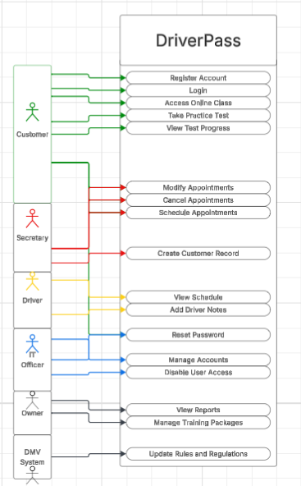

UML Activity Diagrams
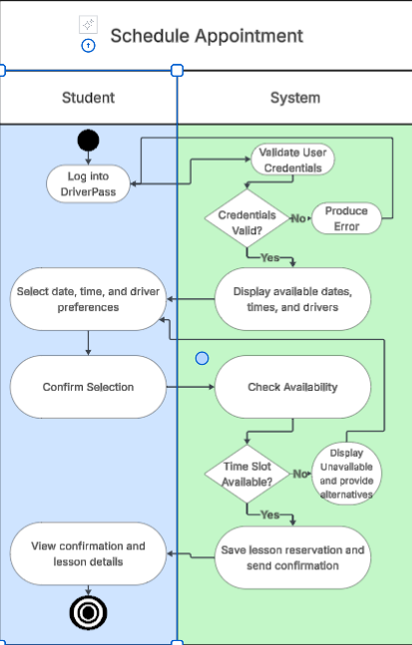

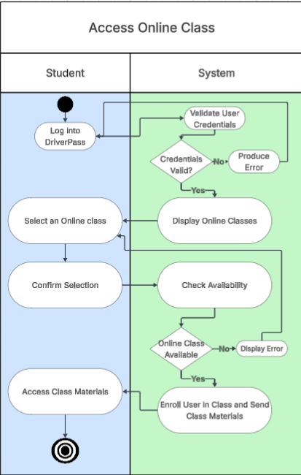

UML Sequence Diagram
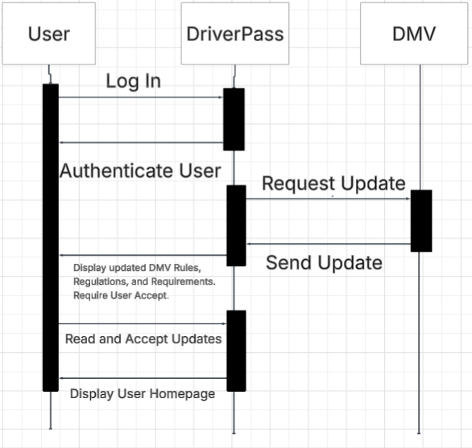

UML Class Diagram
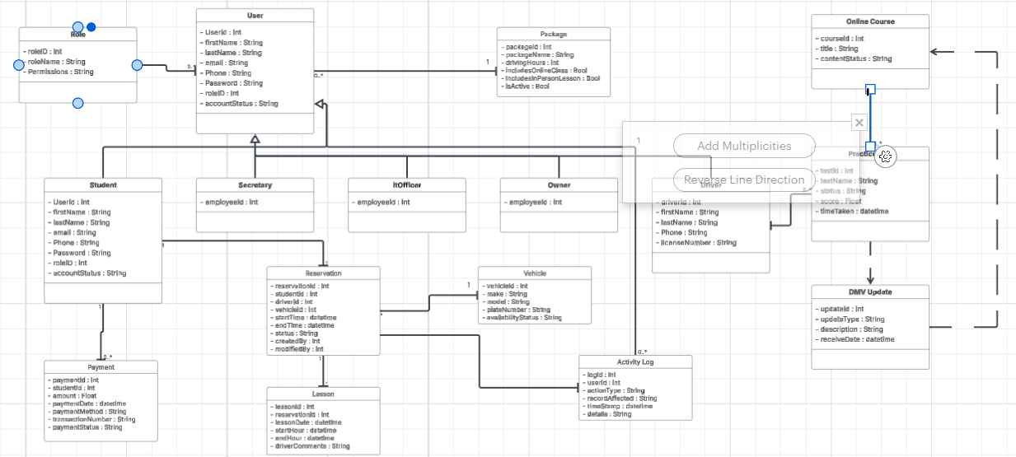

Technical Requirements
The DriverPass system will require a cloud-based web application that can be accessed from desktop computers, laptops, tablets, and mobile devices. Because the client requested access from any computer or mobile device, the system should support modern web browsers and use a responsive interface design. Students, staff, the IT officer, and the owner will all need secure access through individual user accounts with role-based permissions.
The system will require a secure application server to host the DriverPass website, business logic, authentication services, scheduling tools, and online class materials. A relational database will be required to store user accounts, student information, reservations, lesson records, packages, driver information, vehicle information, payment records, practice test progress, DMV updates, and activity logs. The database should support backup and recovery because the client wants the cloud provider to handle security and backups.
The system will also need authentication and account management tools. These tools should allow users to log in, reset passwords, and access only the features allowed by their role. The IT officer must have administrative access to manage user accounts, reset passwords, and block access when necessary. The system should also maintain an activity log that tracks who created, modified, or canceled reservations.
DriverPass will need scheduling infrastructure that checks lesson availability before confirming a reservation. Since each lesson is two hours long and must be assigned to a student, driver, and vehicle, the system must prevent double-booking of drivers and cars. The system should also support online scheduling by students and manual scheduling by the secretary. The system will require integration with the DMV so DriverPass can receive updates about driving rules, policies, and sample test questions. When DMV updates are available, the system should notify users and display updated requirements for review and acceptance.
Required development tools include Lucidchart for UML diagrams, a web development framework for building the user interface and business logic, a relational database management system, secure payment handling tools, and testing tools for validating login, scheduling, role access, online class access, DMV updates, and reporting features. The system should be hosted on reliable cloud infrastructure with HTTPS encryption, database backups, access control, and monitoring. This supports the client’s request for web-based access, reduced technical maintenance, strong security, and the ability to access reports and system data from multiple devices.

